

|  |
| --- |
| Name:  Group Work |
| Student Reference Number: |

|  |  |  |
| --- | --- | --- |
| Module Code: **CNET343SL** | Module Name: **Distributed Systems** | |
| Coursework Title: **Distributed Systems Project 2016/2017** | | |
| Deadline Date: 20/04/2017 | | Member of staff responsible for coursework:  **Mr. Rasika Alahakoon** |
| Programme: 4871/2, 4872/2 | | |
| Please note that University Academic Regulations are available under Rules and Regulations on the University website [www.plymouth.ac.uk/studenthandbook](http://www.plymouth.ac.uk/studenthandbook). | | |
| Group work: please list all names of all participants formally associated with this work and state whether the work was undertaken alone or as part of a team. Please note you may be required to identify individual responsibility for component parts.  10541912 Bandara K G Prageeth K K  10541920 Hewa, K Udayanga  10541922 Algawatta Shamika Dilshan  10541970 Rathnasinghe, P K Chamodi A  10541973 Ratnayake K Basura N B  ***We confirm that we have read and understood the Plymouth University regulations relating to Assessment Offences and that we are aware of the possible penalties for any breach of these regulations. We confirm that this is the independent work of the group.***  Signed on behalf of the group: | | |
| Use of translation software: failure to declare that translation software or a similar writing aid has been used will be treated as an assessment offence.  I *have used/not used translation software.  If used, please state name of software………………………………………………………………… | | |
| **Overall mark _____% Assessors Initials ______ Date_________** | | |



**INDEX NUMBER FULL NAME**

10541912 Bandara, K G Prageeth

10541920 Hewa, K Udayanga

10541922 Algawatta, Shamika Dilshan

10541970 Rathnasinghe, P K Chamodi A

10541973 Ratnayake, K Basura N B (**Team Lead**)

**Degree:** BSc (Honours) Software Engineering

**Stage:** 3

**Batch:** 14.2

**Module:** CNET343SL

**THE**

**FORE RUNNERS**

Believe everything is possible

BUS Riya 1.0 – Public Transporation Redefined

Project Report

Table of Contents

Acknowledgement 1

Declaration 2

Executive Summary 3

Introduction 4

Limitation of System 4

Analysis and Design 5

Problem Identification 5

Proposed Solution 5

UML Diagrams 6

Use Case 6

Activity Diagrams 7

Database 11

Entity Relationship Diagram 11

Normalized Database 12

Features of the System 13

Implementation of Features 13

Passenger Mobile Application 14

Bus Driver Mobile Application 17

Desktop Application 18

Structure of the Whole System 21

Utilized Technologies 21

Server Application 21

Mobile Application 22

Desktop Application 22

Problem Faced during Implementation of the System 23

Team Contribution 24

Basura 24

Chamodhi 24

Dulan 24

Prageeth 24

Shamika 24

# Acknowledgement

The success of any work depends on the encouragement and the guidance. We take this opportunity to express our gratitude to everyone who have been instrumental in the successful completion of this Assignment.

We would like to thank Mr. Rasika Alahakoon for giving us the freedom to choose a scenario of our liking and to build the project based on our own assumptions and ideas and also for his heartfelt support and guidance throughout the successful completion of our project.

**Team ForeRunners**

20th April, 2017

# Declaration

This is to certify that the work contained herein are the sole and original creations of **Ratnayake K Basura N B**, **Algawatta Shamika Dilshan**, **Bandara K G Prageeth K K**, **Hewa, K Udayanga**, and **Rathnasinghe, P K Chamodi A** and that no other external or referential creation/ source by a third-party, other than those cited, were taken-up/ included in the making of this Project. All ownership of this project resides with **TheForeRunners** and all the copyrights of the libraries/API implemented in the project belong to their respective owners.

# Executive Summary

The idea chosen for this project is a BUS Guidance System, we named the project as **BUS Riya** meaning Bus. BUS Riya grants convenience, security and freedom for passengers to manage and check their trips using the public transportation more conveniently and safely.

*“The main purpose of this project is to provide little relief as we can to hard working people who use public transportation to return to their loved ones”*

Time is a precious commodity that must not be wasted in pain therefore to grant more convenience and safety to passengers using public transportation. We introduce a device on every bus that can gather information about a Bus’s location, speed, free seat count. to people before boarding the bus.

With these they can get to know when their bus arrives and how many seats are available in it and also if the bus driver or the conductor is rude or unreasonable it can also be reported to the system for administrative consideration.

Buses equipped with BUS Riya device transmits its location, speed and passenger count every 5 seconds to the main servers. Using the WCF and PHP APIs People with BUS Riya installed on their smartphone (Windows, Android, IOS) can get the location of the nearest bus, how many free seats available and when it will arrive.

# Introduction

This is the documentation of the chosen project idea of BUS Riya. BUS Riya grants clients to manage their public bus transportation usage in a convenient, secure and an independent way by using the mobile application and also grants bus owners to provide an efficient service to their passengers by identifying the current location in a comfortable manner.

As technology is developed widely and brought it to finger tips and as time is a precious commodity that must not be wasted, one of the main targets of BUS Riya is to ensure safety and provide a convenient service to passengers and improve the efficiency and the effectiveness of the public bus transportation. BUS Riya introduces a device for busses that will be able to gather information such as bus location, speed, the approximate time to reach a specific location and the seat availability for passengers. By collecting above data, passengers will be able to check when the bus arrives and the available seat capacity in the selected bus through the mobile application. Moreover, passengers nor the clients will be able to complain through the application itself if there are any inappropriate behaviours of the bus driver or the conductor or about the journey delays.

Buses equipped with BUS Riya device transmit each bus’s location, speed and passenger count every five seconds and upload to the Database using the WEB API. Clients nor Passengers with BUS Riya mobile application installed on their smartphones will be able to find the nearest buses of the current location and the seat availability when the bus reaches for free without doubting their mobiles’ platforms.

## Limitation of System

* App can be only use within a specified area.
* The pressure sensors we use to determine the available free seat capacity can sometimes be false, dues to different body weights of people.
* Arrival time can vary due to road conditions and traffic therefore a near estimate is calculated to get the arrival time.

# Analysis and Design

## Problem Identification

As the major problem found, the passengers use public bus transportation without knowing which bus arrives at what time. Therefore, passengers usually miss buses and even get late for work and school.

The Main problems are classified as below,

* **Inefficiency and Ineffectiveness**

In present, most of the buses do not arrive to pick up points on time and also keep stopping more than the given time period.

* **Bus Drivers / Conductors Inappropriate Behaviours**

Bus drivers’ and conductors’ inappropriate behaviour is common problem, and also passengers can’t complain about those issues easily.

* **Seat Availability**

The passengers cannot check available seats of the buses without getting in. Some busses are full of passengers.

* **Bus Schedule**

In present system, the passengers can’t check bus schedule and available buses on a specific date and a time.

* **Bus Owner’s Lack of Knowledge**

The owner doesn’t have a clue about the travelling of his/her bus.

Considering the above identified problems and situations, an idea called BUS Riya was formulated to satisfy above mentioned problems and the project criteria are to be accomplished.

## Proposed Solution

As all problems can be remedied through technology, the answer to this problem is all computer science. By building a distributed application that can function as a bus guidance system. By overcoming the above realized weaknesses, BUS Riya- Bus Guidance System can be finally obtained as system that any user will be able to use without any limitations.

**Effective and Efficiency**

The clients can easily check the current location and find the nearest busses accordingly and even can check the bus schedule and make a reminder as wishes by providing only a very limited amount of user inputs.

**Legitimate Memberships**

Unique client and bus owner identification and the bus identification is generated to uniquely identify clients, bus owners and busses.

**System Stability**

The system is divided into parts to avoid system crash.

# UML Diagrams

## Use Case

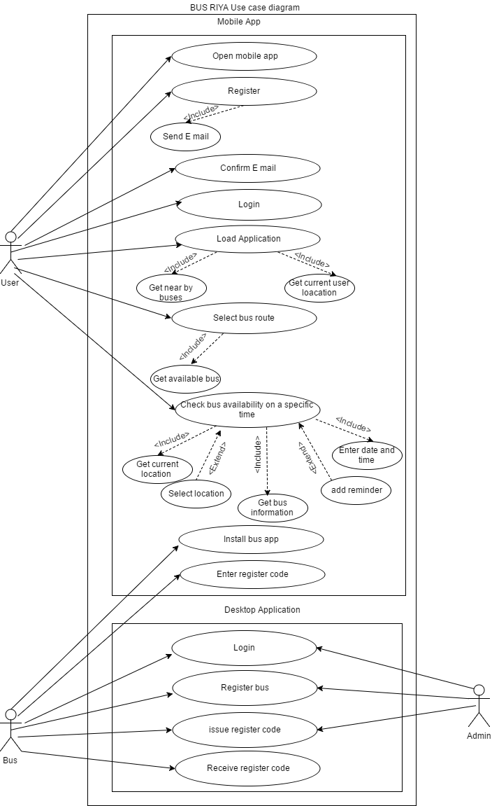

## Activity Diagrams



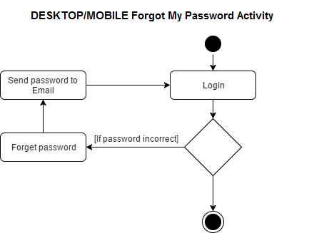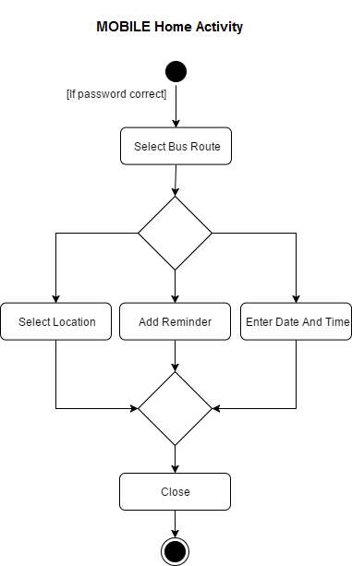

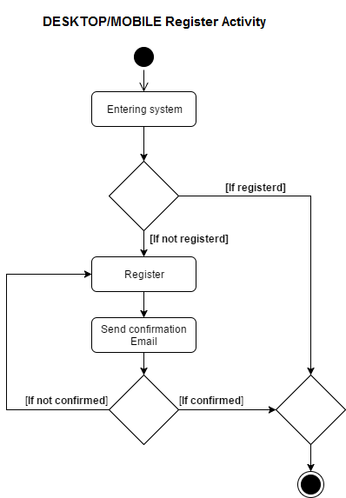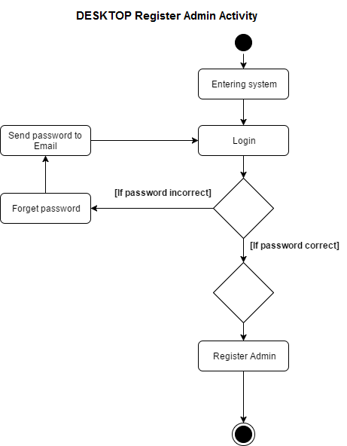

# Database

## Entity Relationship Diagram



## Normalized Database

**Database Name:** busriya_v1

**Table:** AdminLogin

|  |  |  |  |
| --- | --- | --- | --- |
| username | nic | password | email |

**Table:** AdminLogin_History

|  |  |  |  |
| --- | --- | --- | --- |
| adminhisid | nic | login_datetime | logout_datetime |

**Table:** Client

|  |  |  |  |
| --- | --- | --- | --- |
| client_id | fname | lname | tel |

**Table:** ClientLogin

|  |  |  |  |
| --- | --- | --- | --- |
| username | client_id | password | email |

**Table:** Tbl_Token_client

|  |  |  |  |
| --- | --- | --- | --- |
| token | username | time_created | refresh_token |

**Table:** Tbl_Token_admin

|  |  |  |  |
| --- | --- | --- | --- |
| token | usernme | time_created | refresh_token |

**Table:** Route

|  |  |  |  |
| --- | --- | --- | --- |
| route_id | route_no | start_loc | end_loc |

**Table:** Bus_Owner

|  |  |  |  |  |  |
| --- | --- | --- | --- | --- | --- |
| license_no | fname | lname | address1 | address2 | tel |

**Table:** Bus

|  |  |  |  |  |  |
| --- | --- | --- | --- | --- | --- |
| bus_no | license_no | route id | bus_type | seat_cap | cur_seat_cap |

**Table:** Bus_History

|  |  |  |  |
| --- | --- | --- | --- |
| bus_hisid | bus_no | start_date_time | end_date_time |

**Table:** Location

|  |  |  |  |  |
| --- | --- | --- | --- | --- |
| loc_id | cur_longitude | cur_latitude | return | bus_no |

**Table:** Complain

|  |  |  |  |  |
| --- | --- | --- | --- | --- |
| complain_id | client_id | bus_no | date_time | complain_text |

# Features of the System

BUS Riya helps passengers to manage their public bus transportation usage easily in a convenient, secure and an independent way by a few steps with their finger tips and the bus owners to provide an efficient and effective service as passengers expect.

As a result of bus owner/driver and the bus get registered with BUS Riya through the BUS Riya desktop application, any bus will be able to be a part of BUS Riya service. By the device that BUS Riya introduces to every bus after the registration, gathers information about bus locations, speeds, seat availability of every journey and uploads to database in every five seconds through WEB API. Furthermore, the BUS Riya free-mobile application that runs in any mobile platform which can be used by any passenger will be able to check the nearest busses to the current location, bus schedule, the approximate time duration that the bus takes to reach a specific location and also the seat availability of the selected bus through the mobile application. Furthermore, the mobile application itself provides the feature of complaining about inappropriate behaviours and delays for the passengers to ensure the convenient and the secure service.

**Used software applications:** Visual Studio Ultimate 2015, XAMPP, NetBeans, Intel XDE, Cordova

## Implementation of Features

* **Effective and Convenient Search of the Nearest Bus**

The passenger or the client who uses the mobile application would be able to search the nearest buses and a customized search can also be performed to filter busses according to the route number.

* **Data Security**

All data stored are protected with an encryption that can only be decrypted by the administrator username and password. The database access keys are changed regularly to prevent unauthorized access and also the client who uses mobile app also can secure the account created by a username and a password.

* **Easy to Use Graphical User Interface (GUI)**

Users can use the system with ease with the help of the elegant design and the structure of the system GUI.

* **Portability**

Mobile application provides multiple number of users to access the application without complications.

* **Client and Bus Owner/Driver Registration**

The client and bus owner/ driver will get an email for confirmation after registering with the system and the bus owner receives a register code for each bus registers to log with the application that bus owner/driver has to access with the system.

## Passenger Mobile Application

This application is used by the client to get the location, time of arrival and available seat capacity of buses closer to their location.

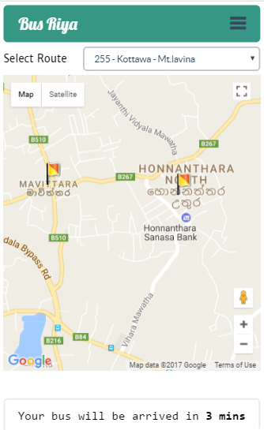**Home Screen**

Through this screen client can see his/her current location and the available buses of the selected bus route and also the nearest bus to client is shown with an estimated arrival time.

**Navigation Panel**

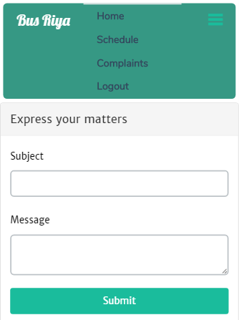This is the navigational area of the app that provides access to specific sections of the app.

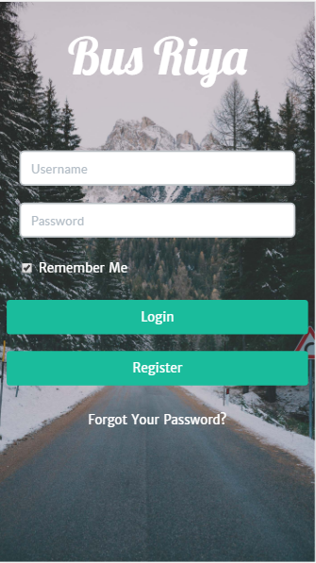**Log In Screen**

This is the login screen of the app used to by the client to gain access to the system.

**Registration Screen**

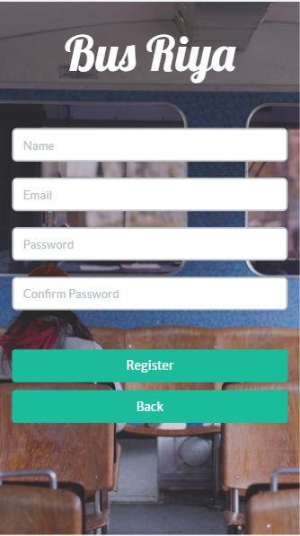If the client does not have an account already in the BUS Riya, by directing to above shown Register screen through the login page it provides a few easy steps to enter name, email, password and confirm password to register and after the registration is done client receives an email automatically as the confirmation email.

**Bus Schedule Screen**

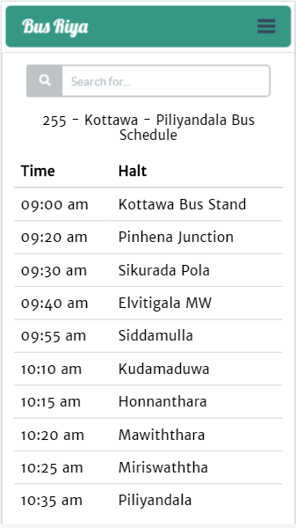Clients also will be able to check the bus schedule of any specific bus through the above screen. Furthermore, will be able to set an alarm or a reminder of any record needed.

**Complain Screen**

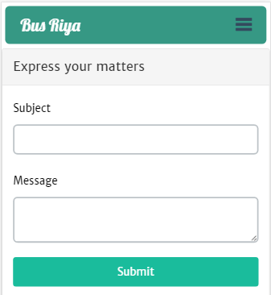Through the shown screen client will be able to complain about the bus delays or the bus driver’s or the conductor’s inappropriate behaviours through the application itself easily.

## Bus Driver Mobile Application

This application is used by the driver of the bus to transmits the location of the bus.

**First Run Screen**

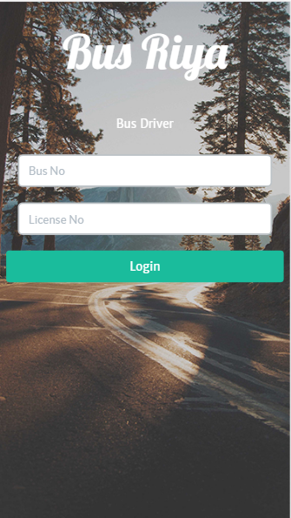This is screen is shown only once when the application is first installed. This provides bus identification details to the system.

**Journey Start/End Screen**

The bus driver must hit Start when beginning the journey and hit Stop when reached the destination.

## Desktop Application

This application is used by the company to perform administrative task on the system.

**Control Panel**

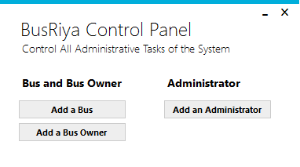Through this screen an administrator can add buses, bus owners, and more administrators.

**Log In Screen**

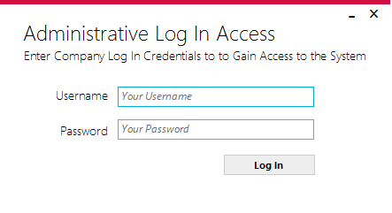This is the administrative login screen of the system which grants access to the system.

**Add Bus Route**

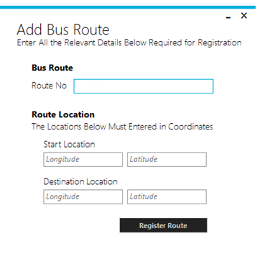This window is used to add new bus route to the system. By filling the above form user can add new bus routes to the system.

**Register Administrator Screen**

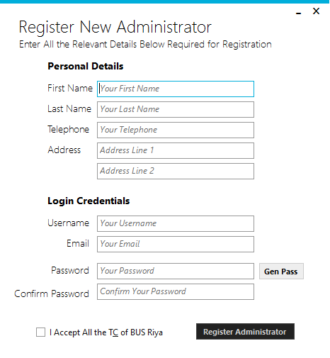When adding a new system user to the system, current valid user need to use above window with the register form. Current User need to register new user with valid data and assign him/her with new user name and a password.

**Register Bus Owner Screen**

When a new bus entered to the system, system requires the bus owner details also. System user need to use the above window to register bus owner with valid data about the bus owner.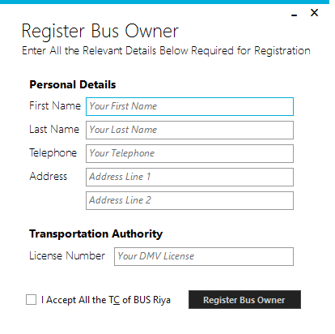

**Bus Registration Screen**

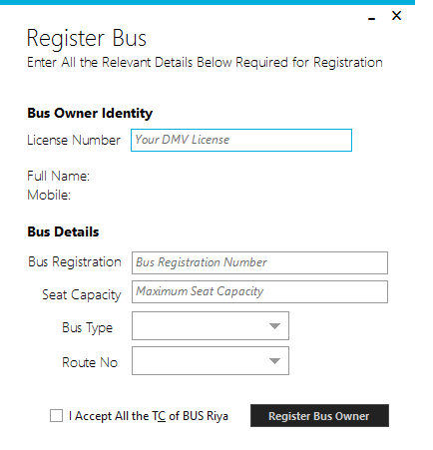When a new bus need to register in the Bus Riya system, Desktop application user need to fill the above form which is displayed on Bus register window with valid data.

# Structure of the Whole System

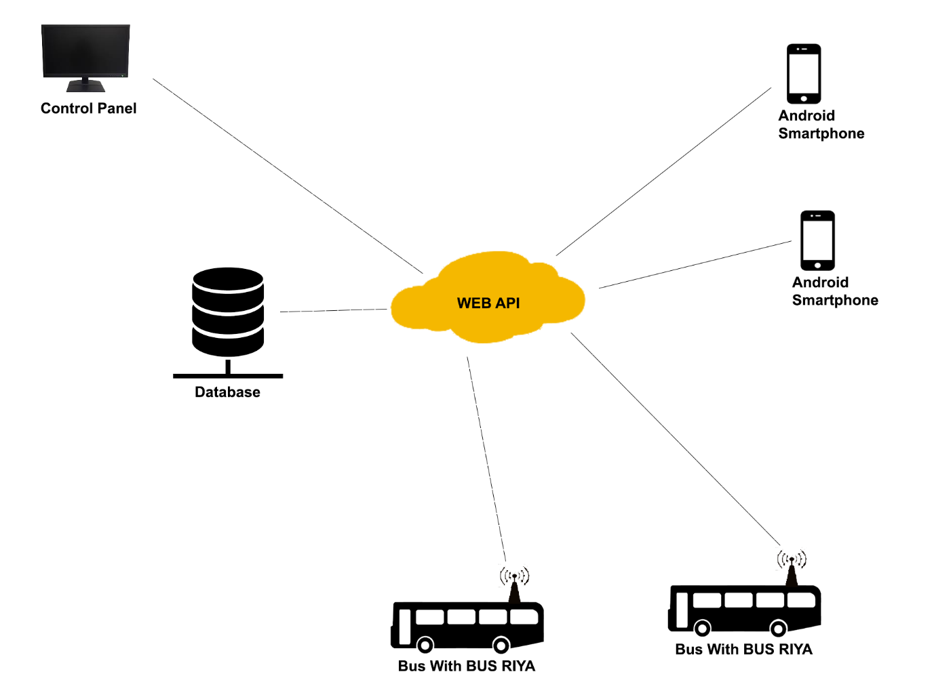

# Utilized Technologies

The system comprises of three main applications (Mobile, Desktop, Server, Electronic Device)

## Server Application

This is the base communication stream of the system which handles all the data transmissions of Mobile, Desktop and Electronic Device Applications.

**WCF**

Acts as the middleware of the system for data transmissions. This framework which is also called as WCF is used for build the service oriented an application to send data as asynchronous messages from one service end point to another.

**MySQL**

Database Management System of the server which communicates through WCF and the Web API.

**PHP API**

Acts as the alternate middleware of the server. This API is utilized in case of communication failure with the WCF service.

**Newton Soft JSON**

Handle the serialization and deserialization of data.

## Mobile Application

This mobile application is a hybrid mobile application capable of running on all smartphone platforms present to the day. Handle all the features of the client side.

**Apache Cordova**

This platform grants the application its cross platform capability.

**Google Map APIs**

Handles all map based location features of the system.

* **Distance Matrix Service**

Google's Distance Matrix service is used in order to generate travel distance and travel duration between bus and the user.

* **Google Map Marker**

used in order to display a map on screen and show bus’s and user’s location with markers.

**Geolocation Web API**

This API is used to obtain the device’s current latitude and longitude and handles all location features

**JQuery based AJAX**

Handles request and responses from/to the server.

**App Framework 3 and Twitter Bootstrap 3**

Used to create the GUIs.

**HTML5/CSS**

Used to create the GUIs.

## Desktop Application

This desktop application is only windows based and handles all the administrative features of the system.

**REST Sharp**

Used to communicate with the server for data transmission. As a result of REST Sharp is an effective library for any sort of .NET innovation, it is used for Windows Phone to utilize REST or SOAP to communicate with external data.

**Newton Soft JSON**

Handle the serialization and deserialization of data.

**Metro Modern UI**

Used to create the GUIs.

# Problem Faced during Implementation of the System

As a group project our common idea is we have succeeded. Finalize output is fully distributed system. When through overall the development process there are various areas that we should deeply concern about. They are how to choose a distribute technology, how we provide a commercial value from this system, what are the crucial features that need to provide in whole application and how to manage heterogenetic capability. Before this project we never implemented a system like this. So lack of experience was a main disadvantage. These are categorized list of problems,

**Managing The Time**

Managing the time with the other module exams and project was challenging. To manage time overall project tasks are divided among all group members and made our own deadlines to finish those tasks. As a result of that able to finish the whole project before given deadline.

**Self-Study and Understanding New Programming And Technology Concepts**

We have developed this application using the c# language. So selecting a distributed technology is a huge part in the research level. After going through several technologies finally RESTful web API and WCF concept was chosen. For this application we have used 4 frameworks. They are WCF, Pure API, Rest Sharp and Cordova. Understanding the developing concepts about these frameworks was not an easy task. Little bit struggled while developing the android application due to lack of experience. We have to find a way to access external server by sending requests through an android device. Eventually understood the concepts and resolved all developing issues.

**Provide A Commercial Value from The System**

Adding a commercial value to project was a challenge. For this we have created an app using Cordova so that it can run on any mobile platform. How to work as a group and getting the idea about managing the time well is additional advantages that learned except the new programming technologies.

# Team Contribution

We used Bit Bucket (<https://bitbucket.org/>) one of the versioning systems to share our project files within team members. Each upload their part once they have added a new feature. Since only a maximum of four people can work on a project at the same time in the free version of bit bucket Shamika and Prageeth had to share one account.

**Bit Bucket User Details**

Basura: <https://bitbucket.org/BasuraR/>

Chamodhi: <https://bitbucket.org/ChamZy/>

Dulan: <https://bitbucket.org/dulan666/>

Shamika/Prageeth: <https://bitbucket.org/shamika123/>

## Basura (20%)

Created the WCF service, the alternate API from PHP and the desktop application. Contributed to the construction of the mobile application.

* WCF Server
* PHP API Server
* Desktop Application
* Mobile Application

## Chamodhi (20%)

Created the database design, UML Diagrams and contributed to the desktop application. Wrote the report and related code related to JSON Strings.

* Desktop Application
* Database
* UML Diagrams

## Dulan (20%)

Created the cross platform mobile application and contributed to the development of the desktop application.

* Desktop Application
* Mobile Application
* UML Diagrams

## Prageeth (20%)

Created the database design, UML Diagrams and contributed to the desktop application.

* Desktop Application
* Database
* UML Diagrams

## Shamika (20%)

Created the database design, UML Diagrams and contributed to the desktop application.

* Desktop Application
* Database
* UML Diagrams